1、配置建交科全部人员
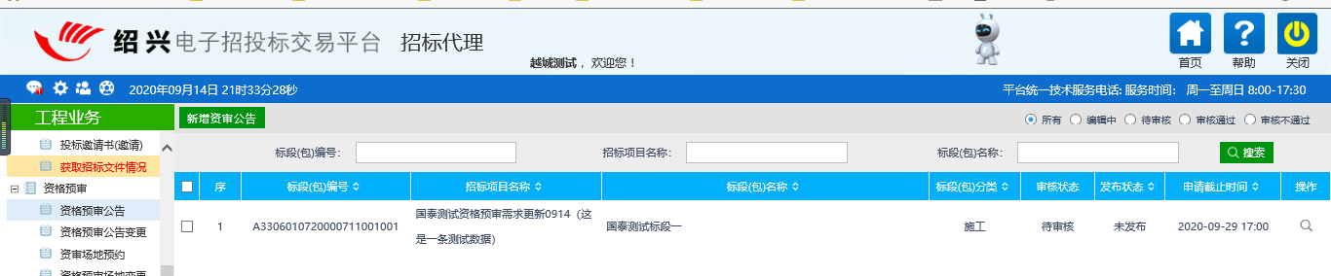
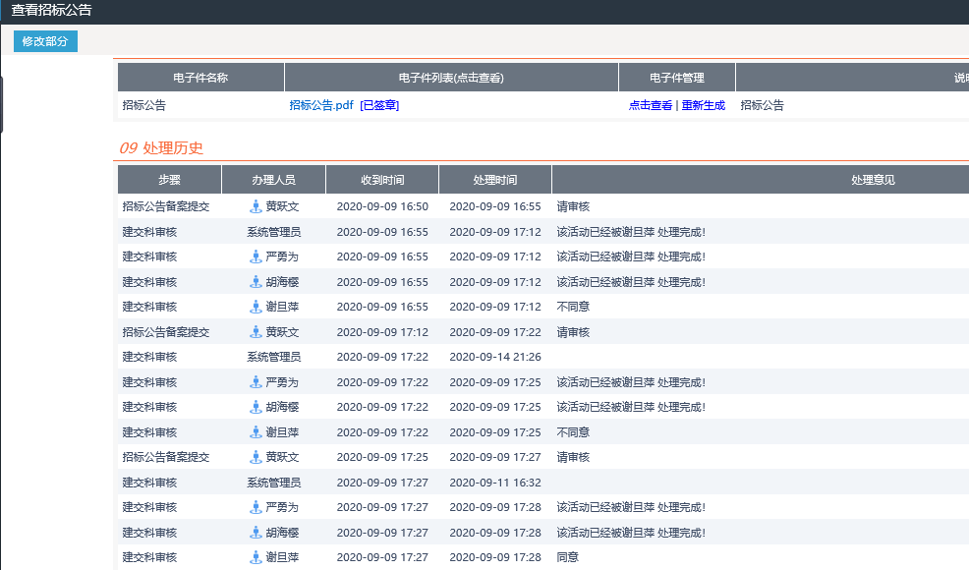
2、同意、不同意
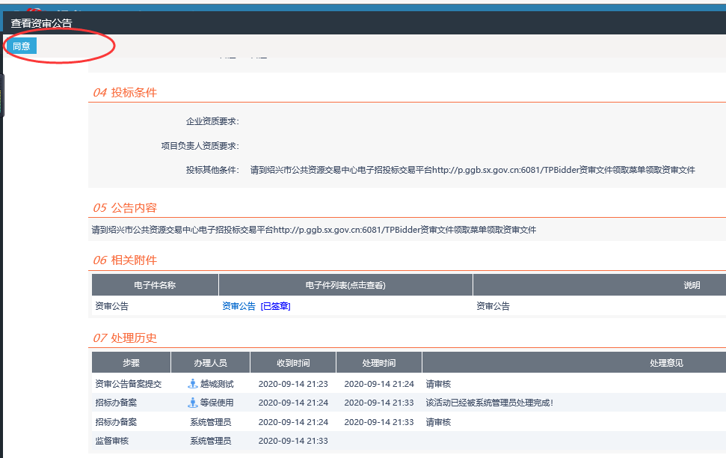
- 补充文件“同意”“不同意”，审核人员不对
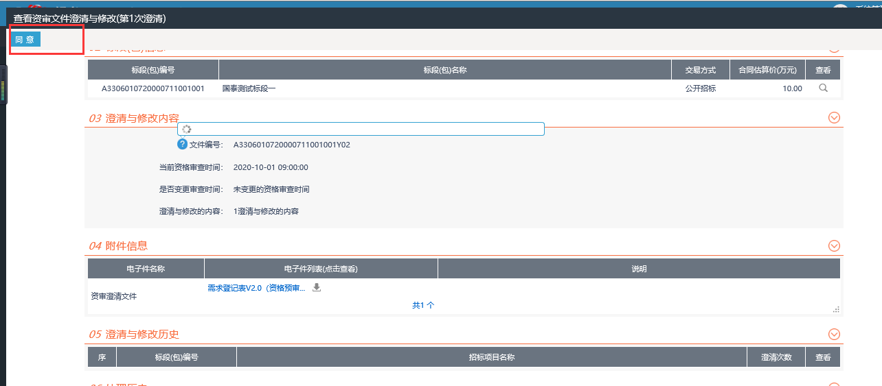
- 答疑回复pdf报错
http://p.ggb.sx.gov.cn:6081/TPBidder/jsgcztbmis2/pages/zishenwjchengqinglingqu_hy/ZiShenWJChengQingLingQu_Detail?Rowguid=09913cee-62e5-431b-829e-eb95f45386fd&_dialogId_=4959012A-900F-4650-A046-7DB7D67C2417&_winid=w9633&_t=828584


